**Supplementary Figure S1**

**Figure S1**. Reaction time plots by monkey. A. Left: Reaction time for accept and reject trials for monkey V. Right: Same as left for monkey W. B. Reaction time vs. choice entropy for accept trials split out by monkey. The correlation was qualitatively weaker in monkey V for accept decisions (RV = 0.47, RW =0.69) compared to reject decisions (RV = 0.82, RW =0.82, Figure 1F). C. Correlation of entropy and reaction time for accept decisions as a function of delay between cue onset and appearance of purple dot. Given the long tail of the RT distribution it is possible that decisions were not fully made at the time of presentation of the purple dot for intermediate offers. This could then drive the correlation between entropy and RT in accept decisions. We would then expect the correlation to be stronger for shorter lapse times between cue onset and presentation of the purple dot. However, this was not supported by our data (panel C).

**Supplementary Figure S2**

**Figure S2**. Fraction of significant neurons for each task factor separated by monkey. N = 8 for each animal. Data are presented as mean values +/- SEM.

**Figure S3**. Fraction of variance explained and individual value component decoding. N = 8 for each animal. Data are presented as mean values +/- SEM. A. Fraction of variance explained as a function of principal components for each monkey. B. Decoding of cued delay interval. C. Decoding of cued reward size.

**Supplementary Figure S4**

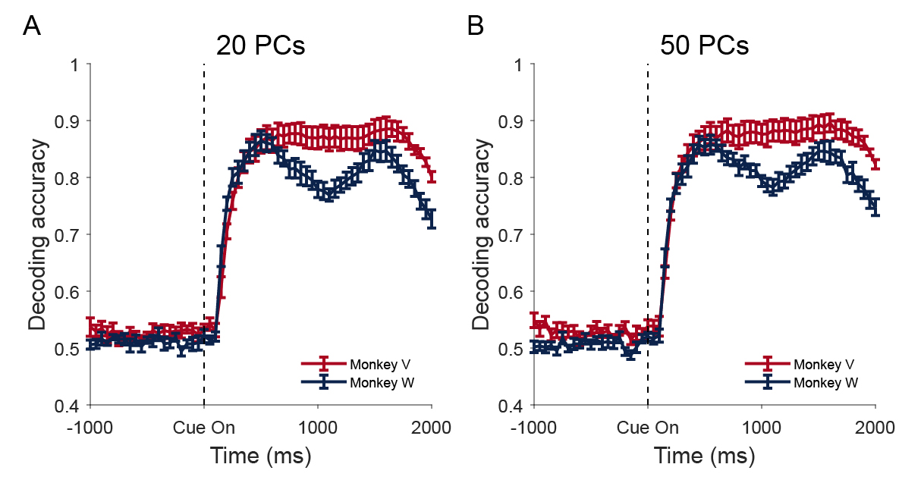

**Figure S4**. Decoding accuracy with 20 PCs (A) and 50 PCs (B). N = 8 for each animal. Data are presented as mean values +/- SEM.

**Supplementary Figure S5**

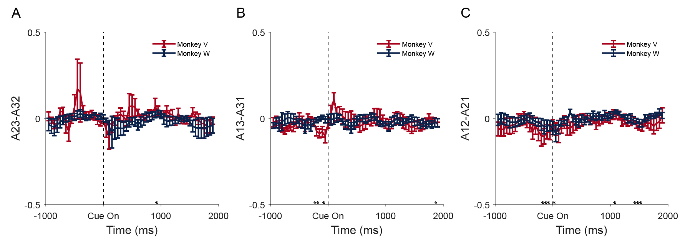

**Figure S5** – Average curls over time in the 3-D subspace. The 3 coordinates of the curl (panels A-C), averaged across sessions, are plotted over time in the three subpanels. Error bars are s.e.m., n = 8 sessions/monkey. Stars indicate single bins that differ from 0.

**Supplementary Figure S6**

**Figure S6.** The manifolds for reject (dotted lines) and accept (solid lines) choices for Monkey V (panel A) and Monkey W (panel B) for intermediate cues. Intermediate cues are defined as cues with p(accept) between 0.25 and 0.75. The lines are separated by the probability of accepting the offer. Positive values in the choice dimensions reflect accept choices. Data are presented as mean values +/- SEM.

**Supplementary Figure S7**

**Figure S7.** Position of mean activity in 1-D choice dimension for each cue. A-B. Position in 1-D choice dimension vs. time for each cue for monkey V (panel A) and monkey W (panel B). C-D. Correlation of position of mean trajectory at the mean reaction time and entropy for accept and reject decisions for monkey V (panel C) and monkey W (panel D). For monkey V, r = -0.72, p < 0.001; for monkey W, r = -0.62, p < 0.001. E-F. Significance of correlation of entropy and position of mean activity over time for monkey V (panel E) and for monkey W (panel F). N = 8 for each animal. Data are presented as mean values +/- SEM.

**Supplementary Figure S8**

**Figure S8.** A. Evidence in favor of choice estimated from behavior (see Methods). N = 8 for each animal. Data are presented as mean values +/- SEM. B. Correlation of the behaviorally extracted evidence $z_{i}$ and the evidence term fitted from the neural data $h_{i}$ over time. N = 8 for each animal. Data are presented as mean values +/- SEM. C and D. Correlations between $z_{i}$ and $h_{i}$ at the mean reaction time for monkey V and W respectively. For monkey V, r = 0.82, p < 0.001; for monkey W, r = 0.67, p < 0.001.

**Supplementary Figure S9**

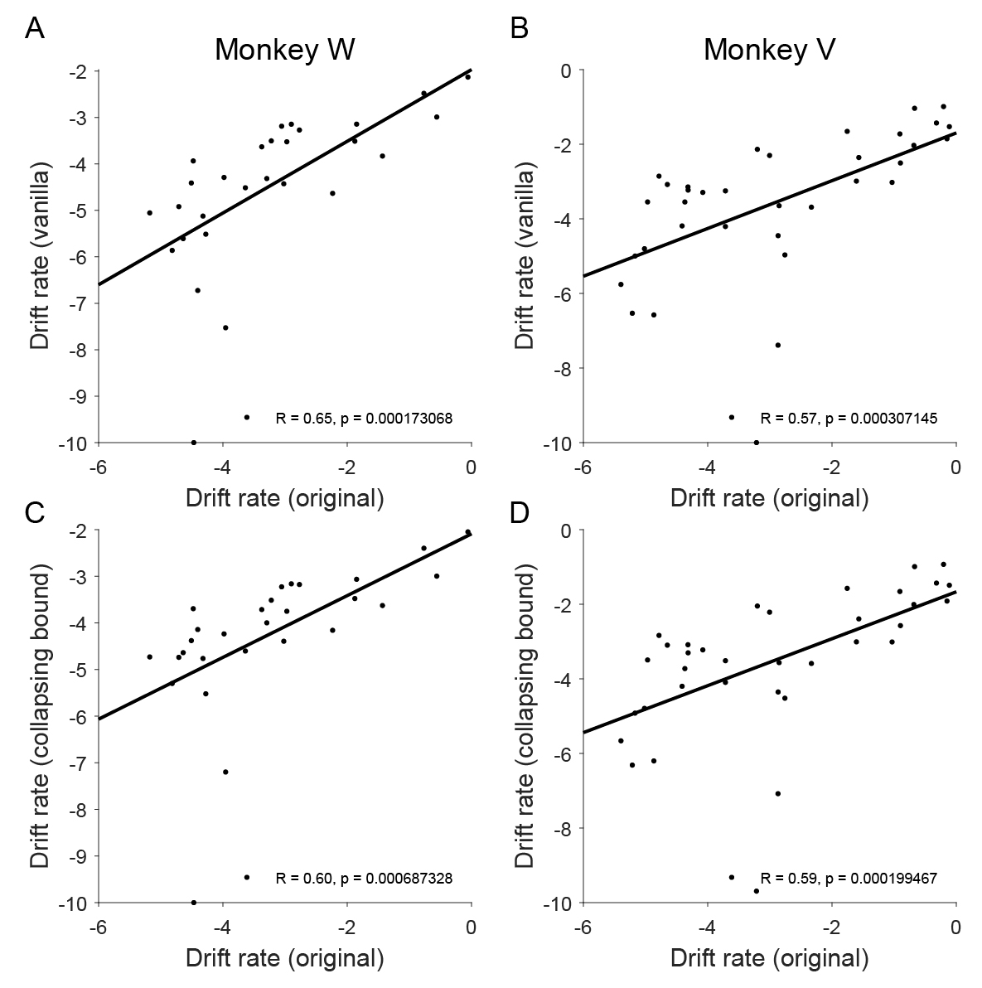

**Figure S9.** A and B, Correlation between DRoriginal and DRvanilla. C and D, Correlation between DRoriginal and DRcollapsingbound.

**Supplementary Figure S10**

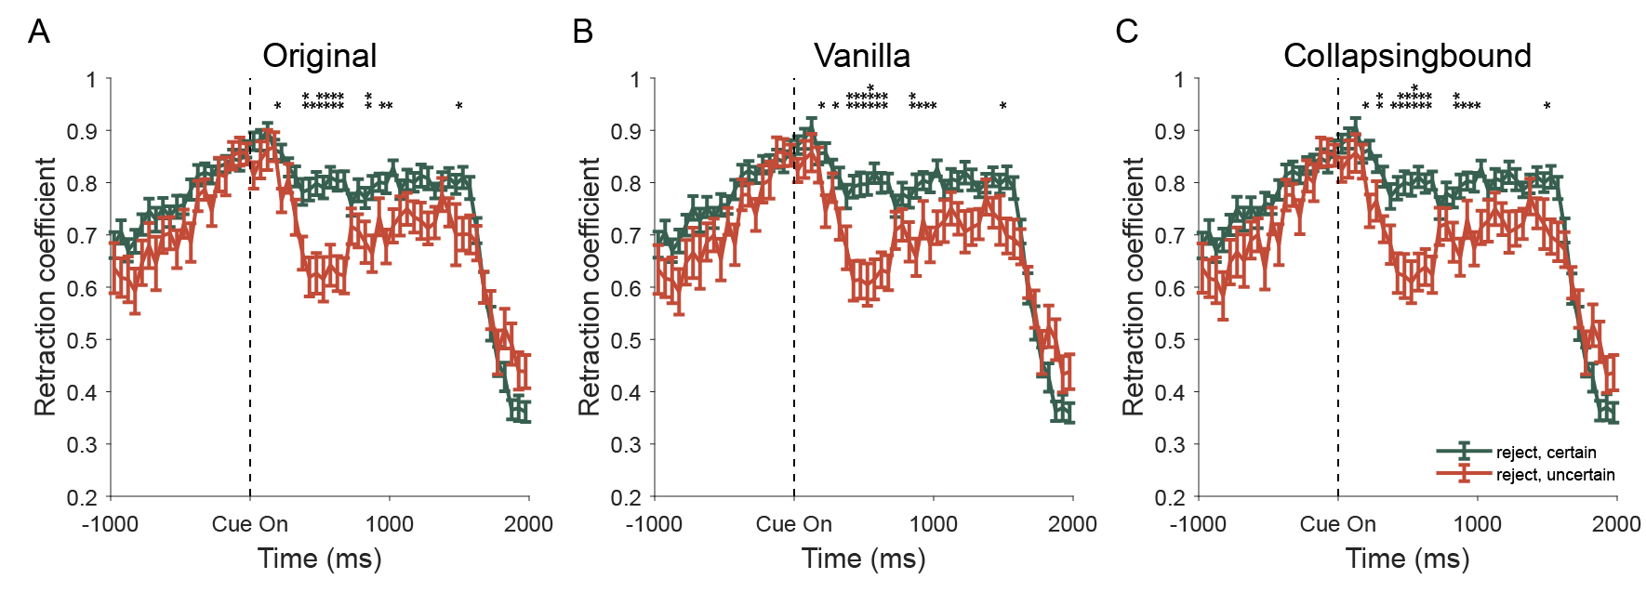**Figure S10.** Retraction coefficients are higher for consistent choices. N = 8 for each animal. Data are presented as mean values +/- SEM. Panels A-C are for the three different DDM models: original method, vanilla DDM, and DDM with collapsing bound.

**Supplementary Figure S11**

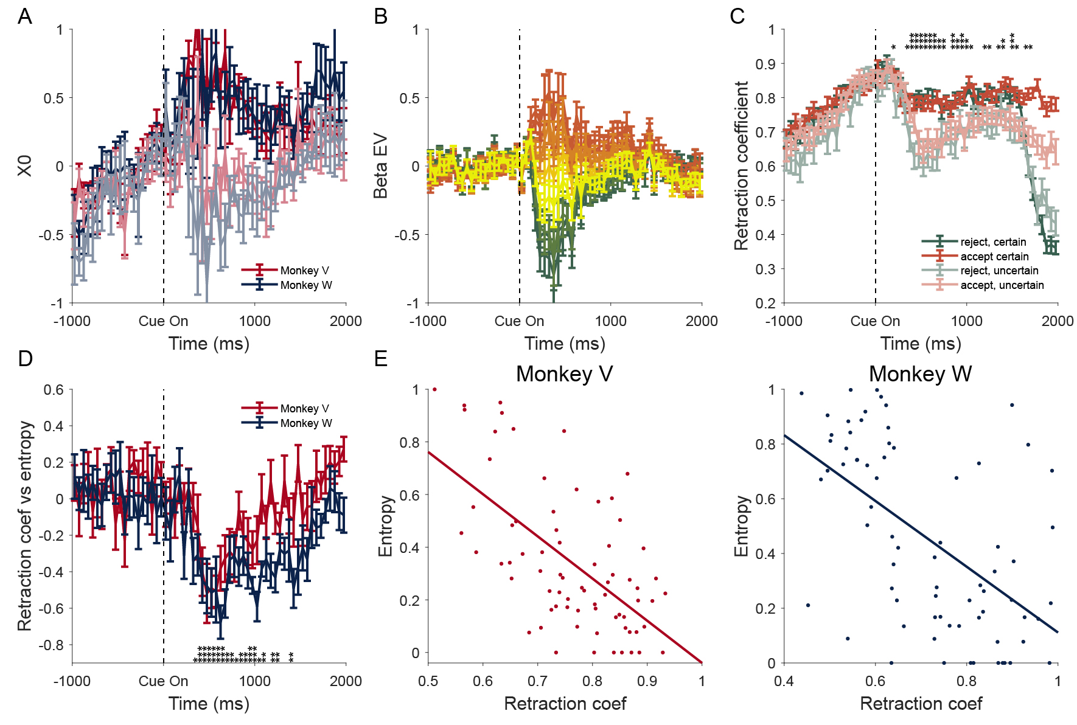

**Figure S11.** Parameters in the evidence model. Error bars represent standard error of the mean. For plots that show data separately for each monkey, N = 8 as SEM was computed across sessions for each animal. A. Choice related activity, characterized as the undriven fixed points, $x_{0,j},$ over time. Note the darker color curve is accept decision and lighter color curve is reject decision, for each monkey. B. Strength of evidence-driven neural activity over time by offer cue. The colors reflect p(accept), red reflects cues signaling offers that monkeys mostly accept, green reflects cues signaling offers that monkeys mostly reject, and yellow reflects cues signaling offers that monkeys have intermediate probabilities of accepting. C. Retraction coefficients are higher for consistent choices. D. Retraction coefficient significantly correlates with choice entropy across the 9 cues. E. Correlation between retraction coefficient and choice entropy at median reaction time for Monkey V (left) and Monkey W (right). For monkey V, r = -0.62, p < 0.001; for monkey W, r = -0.56, p < 0.001.   
* = 0.05, ** = 0.01, *** = 0.001

**Supplementary Figure S12**

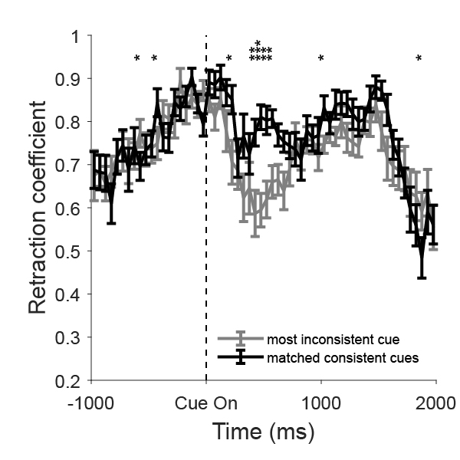

**Figure S12** – In this analysis, we considered the most inconsistent cues (for example, Monkey W accepts the “4 drops 5 seconds” cue 59% of the times) and the most consistent accept (Monkey W accepts the “6 drops 1 second” cue 97% of the times) and reject cues (Monkey W accepts the “2 drops 10 seconds” cue 0.01% of the times). We sampled from the most consistent accept and reject cues the same number of accept and reject trials as were available for the most inconsistent cue. Thus, the number of accept trials available for the consistent accept condition was matched to the number of accept trials available for the inconsistent condition, and correspondingly for the reject trials. We repeated our analysis and calculated the retraction coefficient using datasets composed of these sub-sampled trials. Our analysis suggests that the retraction coefficient was significantly larger even after matching the number of trials in the different conditions. N = 8 for each animal. Data are presented as mean values +/- SEM.

**Supplementary Figure S13**

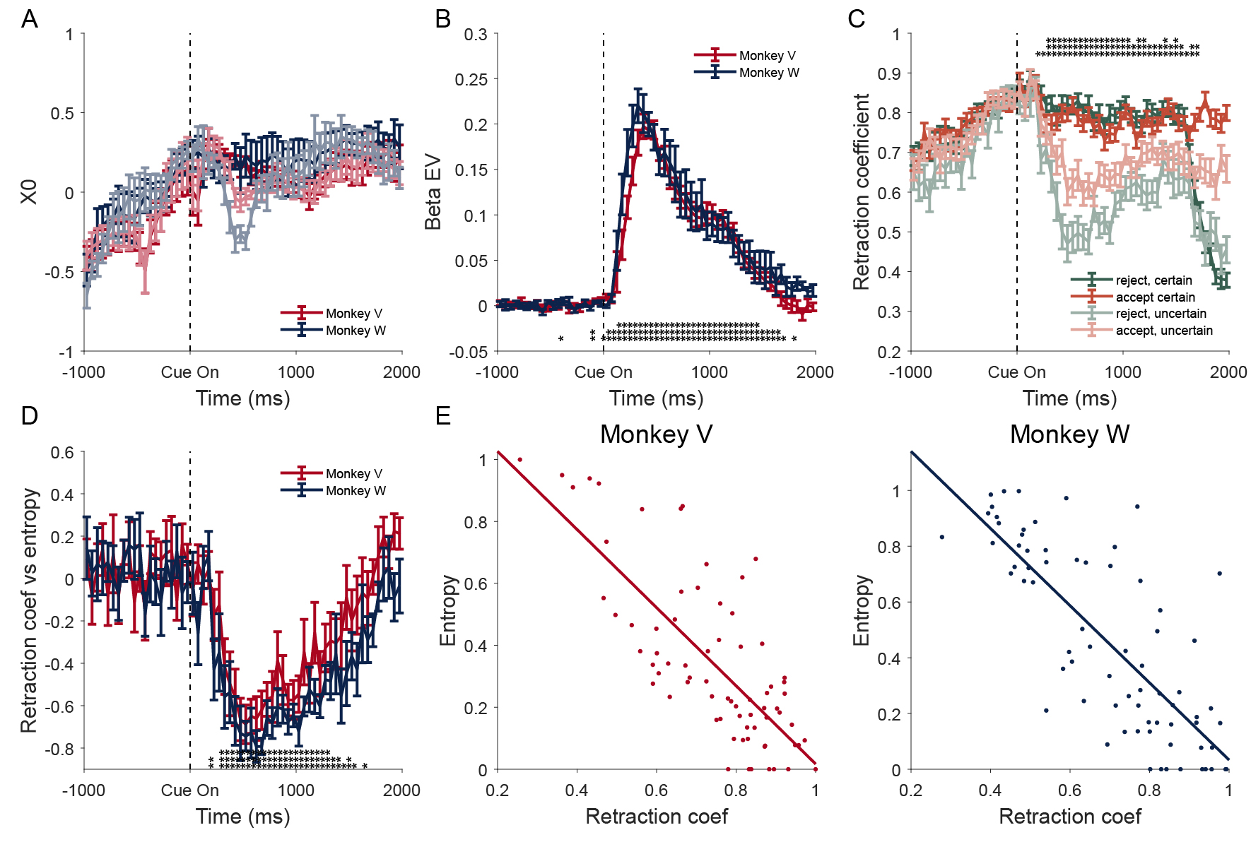

**Figure S13**. Panels are the same as Fig. 5. N = 8 for each animal. Data are presented as mean values +/- SEM. Moment-by-moment decoded choice was used in place of the final choice in behavior. In panel A, light colors are undriven fixed point for reject decisions and dark colors are for accept decisions. In panel E, for monkey V, r = -0.76, p < 0.001; for monkey W, r = -0.79, p < 0.001. * = 0.05, ** = 0.01, *** = 0.001

**Supplementary Figure S14**

**Figure S14.** Model coefficients estimated when activity projected on choice-dimension estimated by vector difference in means for accept vs. reject decisions. A-E. Model parameters for dynamics model after data projected onto the 1-D choice dimension defined by the difference in mean responses for accept and reject trials. N = 8 for each animal. Data are presented as mean values +/- SEM. Significance values as in Fig. 5. E. For monkey V, r = -0.45, p < 0.001; for monkey W, r = -0.56, p < 0.001. F. Correlation between retraction coefficients defined in the 1-D choice dimension defined by either the SVM or the projection onto the line defined by the difference in mean responses for each condition. The retraction coefficients were strongly correlated (r = 0.78, p < 0.001).

**Supplementary Figure S15**

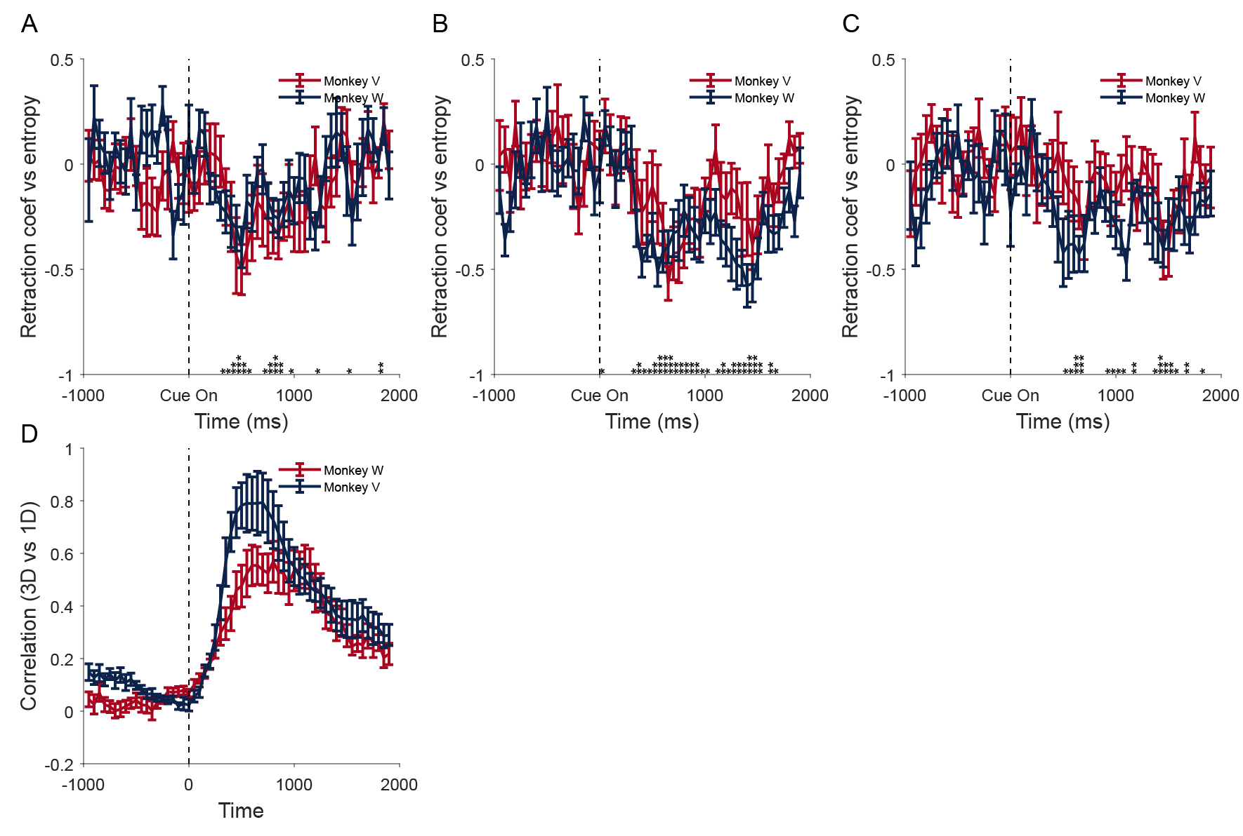

**Figure S15** – A-C. Correlation between the three eigenvalues of the retraction matrix for each cue, and the behavioral entropy of that cue. D. Alignment of the vector connecting the 3D undriven fixed point and the 1-D choice dimension. N = 8 for each animal. Data are presented as mean values +/- SEM.

**Supplementary Figure S16**

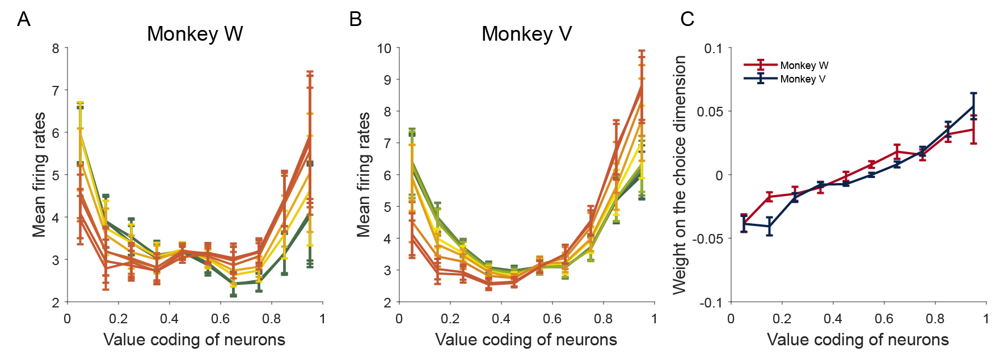

**Figure S16** – A and B. Mean firing rates of neurons in response to different offers as a function of value-coding, where 1 is preference for better options, and 0 is preference for worse options. C. Weight of each neuron on the 1-D choice dimension as a function of value coding. N = 8 for each animal. Data are presented as mean values +/- SEM.

**Supplementary Figure S17**

**Figure S17** – A-C. Correlation between the retraction coefficient for each cue, and the behavioral entropy of that cue. D-F. The retraction coefficients over time for certain vs uncertain cues. N = 8 for each animal. Data are presented as mean values +/- SEM.

**Supplementary Figure S18**

**Figure S18** – Retraction coefficients vs accept reaction time. A. The correlations between retraction coefficients and reaction time for accept decisions over time. N = 8 for each animal. Data are presented as mean values +/- SEM. B. The correlations between retraction coefficients at average reaction time for reject decisions and reaction time for accept decisions (monkey V, r = -0.05, p = 0.753). C. Same as B for monkey W (monkey W, r = -0.38, p = 0.021).

**Supplementary Figure S19**

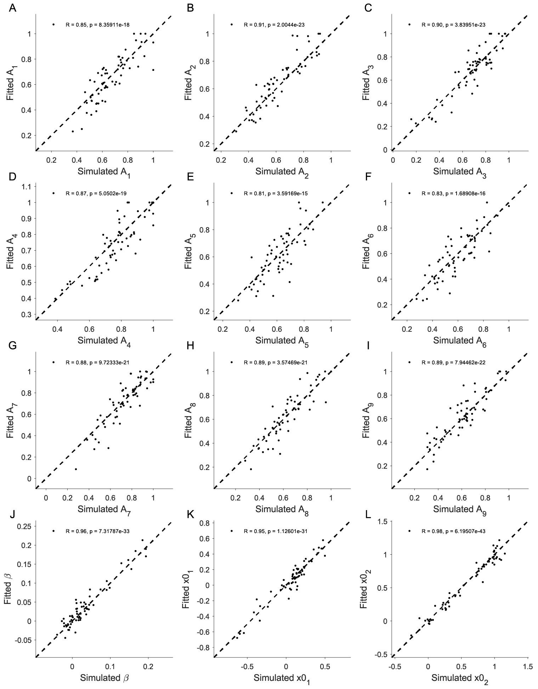

**Figure S19** – Parameter recovery for the linear dynamical system model. $A_{1}$ to $A_{9}$ are the 9 different cue-specific retraction coefficients (panels A-I). $X_{0_{1}}$ and $X_{0_{2}}$ are the undriven fixed point for reject and accept decisions, respectively (panels J-K). $β$ is the evidence accumulation coefficient (panel L). Dotted line is the diagonal line.

**Supplementary Figure S20**

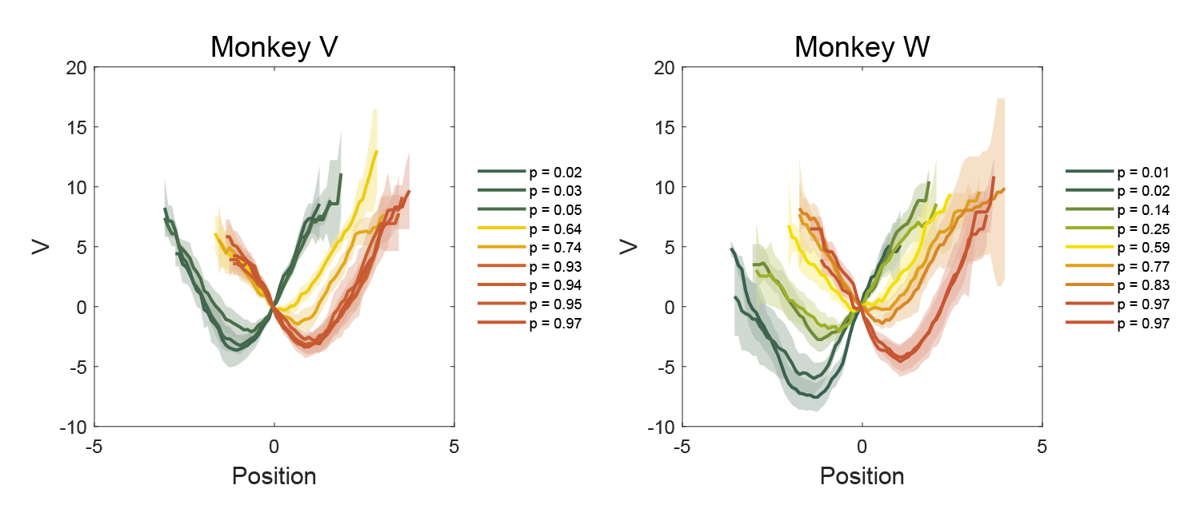

**Figure S20** – Posterior predictive checks: energy landscape for simulated data from the linear dynamical system model. Data are presented as mean values +/- SEM.